**Project 1:**

Pebble Africa Database Development

**Project goal:**

Create a cloud database for Pebble Africa so they can start storing information in a database. They are currently using Excel as the source of data collection and storage.

**Project tools:**

* PostgreSQL
* ElephantSQL server
* Diagrams.net

**Steps to complete the project:**

1. Create an ERD of the database
2. Set up a cloud server for the database
3. Create schemas for the database
4. Populate schemas with tables

**Step 1: Create an ERD of the database**

**Tool used:** Diagrams.net

Pebble Africa is a company that makes and sells pebbles used for agricultural purposes. They buy certain stones from a mine, crush the stones into smaller pebbles, sort it and package it. The pebbles get sold and shipped to reseller companies.  
  
They need the following tables in the database to store business critical information:

1. Mine table – for the different mines they purchase stones from
2. Employees table – all the people working for them
3. Stock table – they keep stock of different pebbles and different sizes
4. Customers table – a list of the resellers they supply stock to
5. Transport table – a list of companies that deliver stone from the mines or deliver pebbles to the resellers
6. Orders table – for all the orders the company processed
7. Order items table – for the list of items per order

Quick database tables mockup:



Pebble Africa EDR:

**Step 2: Set up a cloud server for the database**

**Server provider:** ElephantSQL

**Reason:** Free tier available for small databases. They provide a single free database with up to 20MB server space.

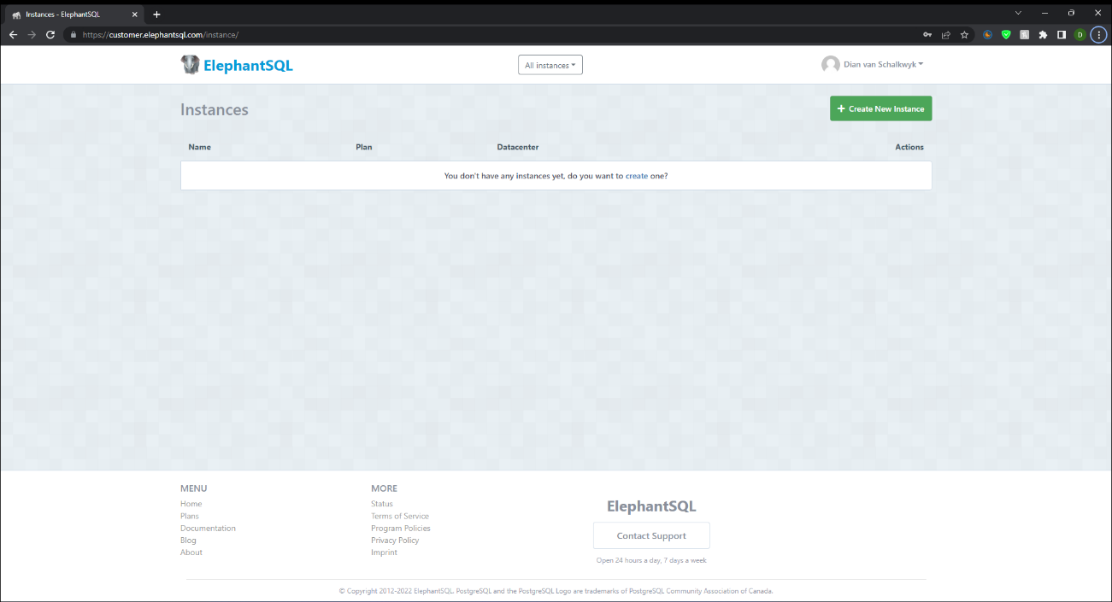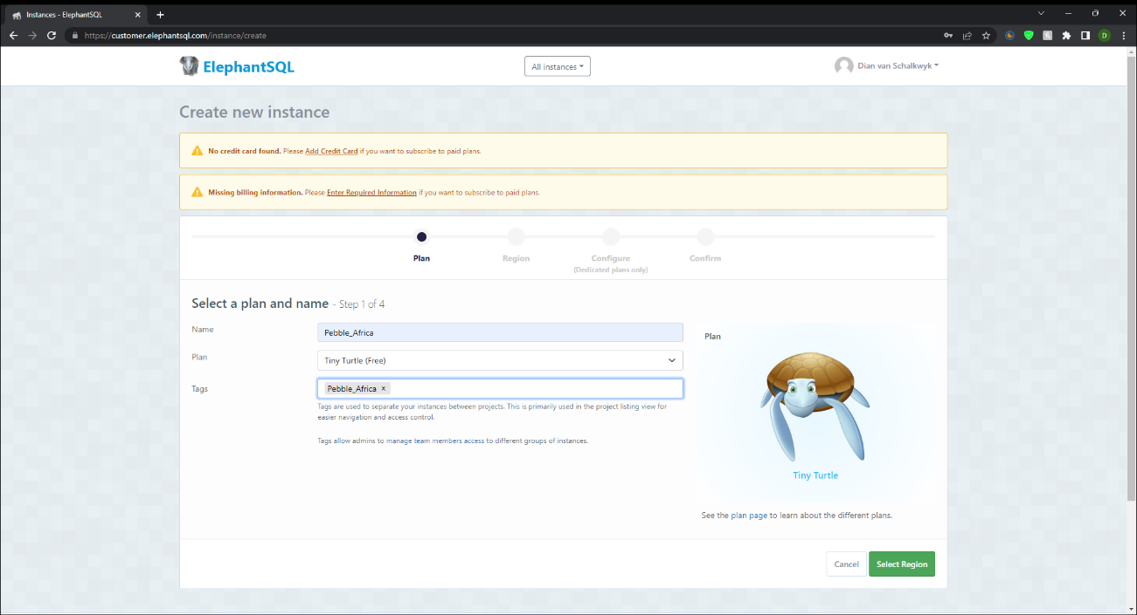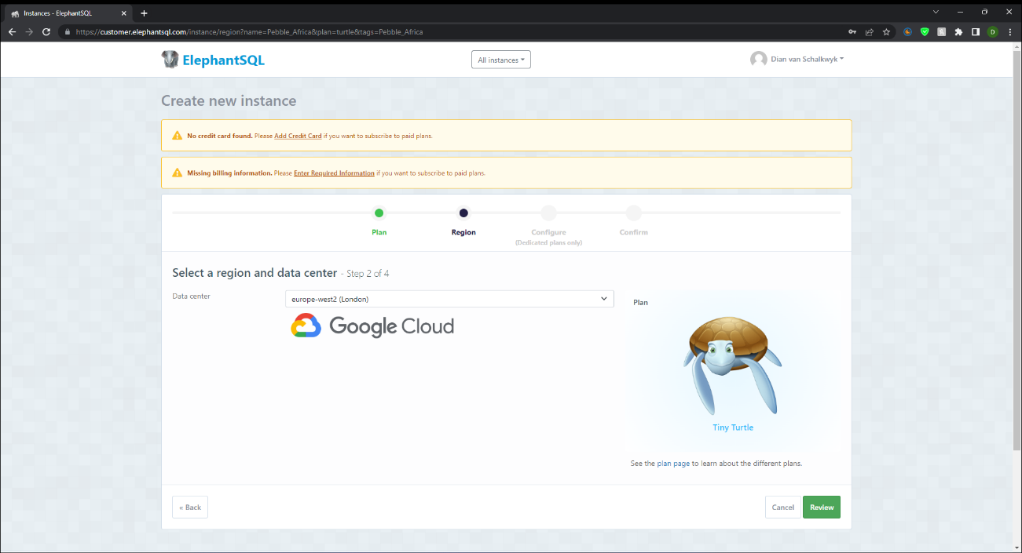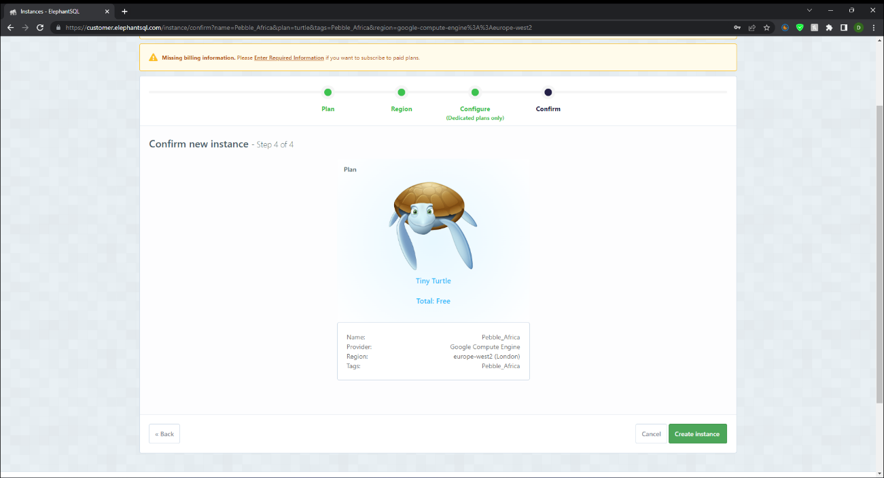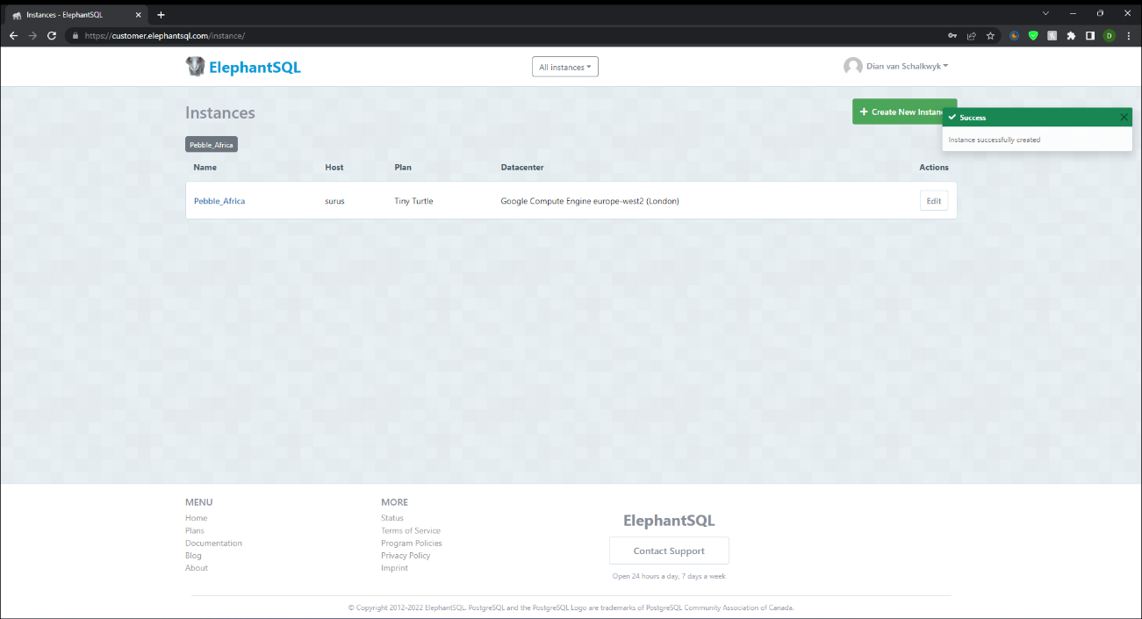

Creating a database for a small company on ElephantSQL is extremely fast. I can scale the database as needed in the future when the company needs more space, for additional cost.

**Step 3: Create schemas for the database**

**Tool used:** SQL Shell (psql)

Schemas needed:

1. Human resources
2. Administration
3. Inventory
4. Sales

SQL code to create schemas:

1. Human resources:



1. Administration:



1. Inventory:



1. Sales:



All schemas created successfully:

**Step 4. Populate schemas with tables**

1. Human resources schema: EMPLOYEESText

   Description automatically generated
2. Administration schema: CUSTOMERS / TRANSPORT / MINESText

   Description automatically generated

1. Inventory schema: STOCK

1. Sales schema: ORDERS / ORDERITEMS

List of all the tables created:

